Recognition

The recognition algorithm operates on rectangular regions of interest known as chips. Within these chips, it compares elliptical areas of similarity known as hotspots, or more generally, patch-based features.

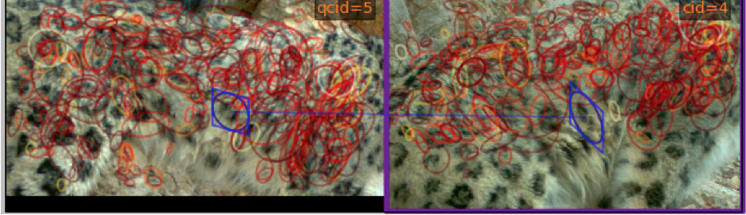

Figure 1: Example of hotspots on the body of a snow leopard

The keypoint associated with each feature contains information about xy-location of the feature within the image, as well as scale, orientation, and shape.[1]This additional information allows the program to account for the size of the feature, as well as different angles of viewing the animal and different poses, effectively allowing recognition between one sighting of an animal and another. However, since it is not desirable that hotspots be allowed to transform freely in reference to nearby hotspots, HotSpotter implements a process known as spatial verification. Spatial verification limits the potential chip-to-chip feature matches by ensuring that hotspots transform similarly to their neighbors. Any feature match that is found to be spatially inconsistent is not considered when computing a similarity score.

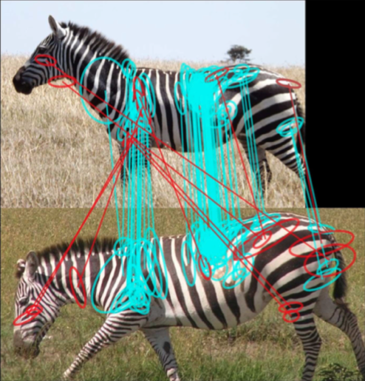

Figure 2: Example of spatial verification on a zebra image. Inconsistent matches are shown in red

Spatial verification works by fitting a rigid projective transformation to the chip. Currently, spatial verification only checks spatial location. The actual recognition is performed using an algorithm similar to Local Naïve Bayes Nearest Neighbor search [1].

The HotSpotter recognition algorithm is well tested on animals with relatively rigid bodies, e.g. zebras. However, snow leopards present a challenge in that their bodies are particularly lithe and flexible, and their fur is long. This fluffiness can sometime occlude identifying features such as spots. The effect these constraints will have on recognition accuracy is unclear, and thus it is necessary to thoroughly test the accuracy of the existing algorithm and determine if modifications are necessary to improve performance. This will involve testing on many cases of snow leopard images (e.g. cats at varying distances from the camera, levels of lighting, body position, etc.) and recording the results. Problem cases will be noted, and from this information, as well as knowledge of the recognition algorithm, the team will determine if modifications to improve the accuracy of the recognition algorithm are possible. Some possible candidates that are under consideration are modifications to the spatial verification, e.g. expanding it to check additional dimensions (possibly scale and orientation), or modifying the transformation it uses to map hotspots, possibly implementing a non-rigid projective transformation.

[1] HotSpotter uses a Hessian-based keypoint detector, which detects blobs